REGISTER NEW ZEALAND
NEWSLETTER SEPTEMBER 2018
Greetings again to the V8 converted. Some facts from the MGCC V8 Register, a record price sale for a restored factory GT, John Badham’s V8 conversion, Ross and Ann Armstrong’s ZTT 260.
First, a mod done to ‘Grumpy’, my 75 GT has made the car a much nicer place to be. I recently replaced the front springs off my Moss coil overs which were extremely hard and produced a very hard ride on the highway. Not being able to determine what the spring rating was, I decided to simply go back to the 475lb standard rating that Moss recommended for the GTV8. This has made for a more normal comfort level with little difference in handling, also Ruth doesn’t have to brace herself every time a large bump in the road appears, a huge bonus. Good result all round.
I have been checking Trademe regularly for any cars that are not already on the Register and there still appears to be a small but steady stream of RV8’s coming in from Japan. Carjam helps in getting the numbers of these cars. The Register now has 151 MG V8’s listed and a few that I am unable to confirm for various reasons. The breakdown of the different models is listed below.
Factory original GT – 18
Converted GT - 60
Converted MGB Roadster – 9
Costello – 1
Brayshaw – 3
Converted Magnette – 1
RV8 – 54 ( the vast majority imported from Japan)
ZT 260 – 3
ZTT 260 – 2
There are almost certainly more MG V8’s around that are not currently on the Register so if you happen to know of any please let me know.

Recently a fully restored Factory GTV8 sold on Trademe for what is probably a New Zealand record price of $61,100. I have met the new owner of this car and he is, as would be expected very pleased with his new purchase. Other V8’s on Trademe also seem to be fetching very good prices as have the 4 cylinder MGB’s and GT’s that are in exceptional condition. This would point to the fact that good examples of these models are appreciating and are well worth looking after, hopefully the trend will continue.
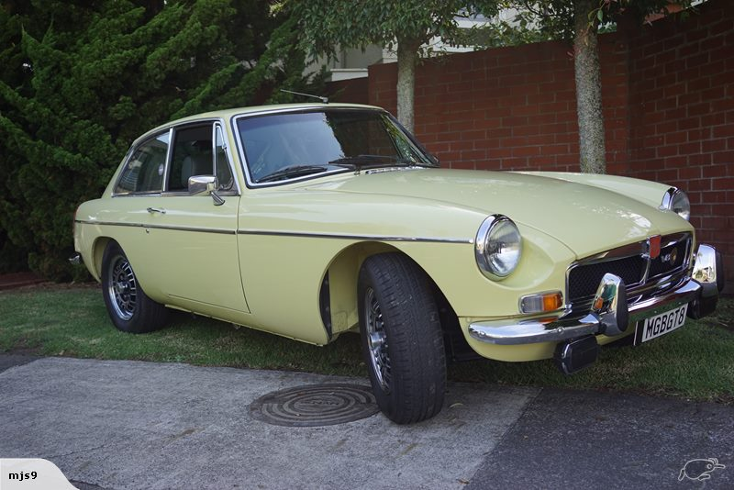
1974 Primrose Sold for $61,100.

John’s new love affair

You may have seen a British racing green MGB GT V8 at some of the Auckland MGCC events, some members have asked for some details about the car and how it came about for others with V8s in the Register.
The car was a rubber bumper 1976 model painted red. It belonged to a Peter Crossan in Napier. Peter was a Coach builder by trade. The car first had a turbo charger fitted to the 1800cc motor before the V8 came along. Peter wasn’t happy with the final speed increase that the turbo gave so decided on a complete rebuild. So, this is the story.
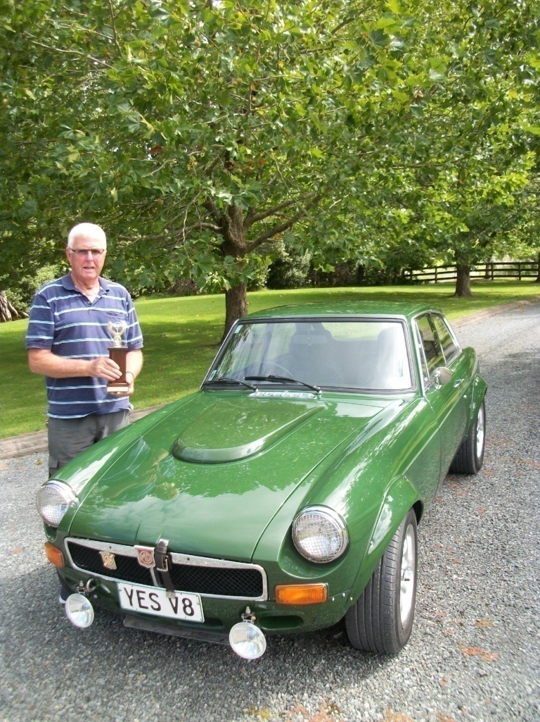

The car was stripped down to bare metal, rust protected throughout. Each door was stripped and rebuilt and all the hardware polished and re-plated. Noise deadening flooring fitted (Dyna mat). Complete front end rebuilt with new adjustable telescopic shocks all round, new front springs and heavy-duty sway bar, new brake rotors and pads. New tail light fittings as the old were faded with age. So now he needed a power plant.
Peter found a Rover SD1 for the donor motor 3500cc that was one of the last of the models with the bigger valves.
The motor was removed and sent to Quality Auto Machinists (1988) Ltd in Hastings to do a complete rebuild. It was re-bored, new pistons fitted, crankshaft grind and balance and new bearings. A Crane high performance cam was fitted. The engine was then mated to a Toyota Celica W55 5 speed gear box. It was then ready to go back into the then repainted car. Because of the different gearbox a new heavy-duty drive shaft and yokes had to be built and balanced. With the extra horsepower a new heavy-duty clutch was fitted, and the fly wheel lightened and balanced.
Because of the bigger motor a new hi volume 4 core alloy radiator was fitted with twin electric fans.
With full flow headers, large exhaust and a four-barrel Edelbrook carburettor the car sounds awesome, is very quick and revs beautifully.
In its final livery it had panels fitted to the front and rear to give it the Sebring look without bumpers, flares fitted to the guards to accommodate the bigger tyres.
Peter’s circumstances changed and as result he placed the car on Trademe last November. A lucky MGCC member John Badham of Warkworth spotted it and snapped it up sight unseen, he was the only bidder and considers he got a beautiful car. John says it may not be to everyone’s taste without the chrome bumpers but where ever the car is seen it draws a crowd. In fact, it won at the “Galaxy of Cars” held at Western Springs, it was awarded best of show by the magazine “Classic Driver” John has been offered considerably more for the car than what he paid for it but wouldn’t sell it, John says it’s a one off and so much fun to drive.

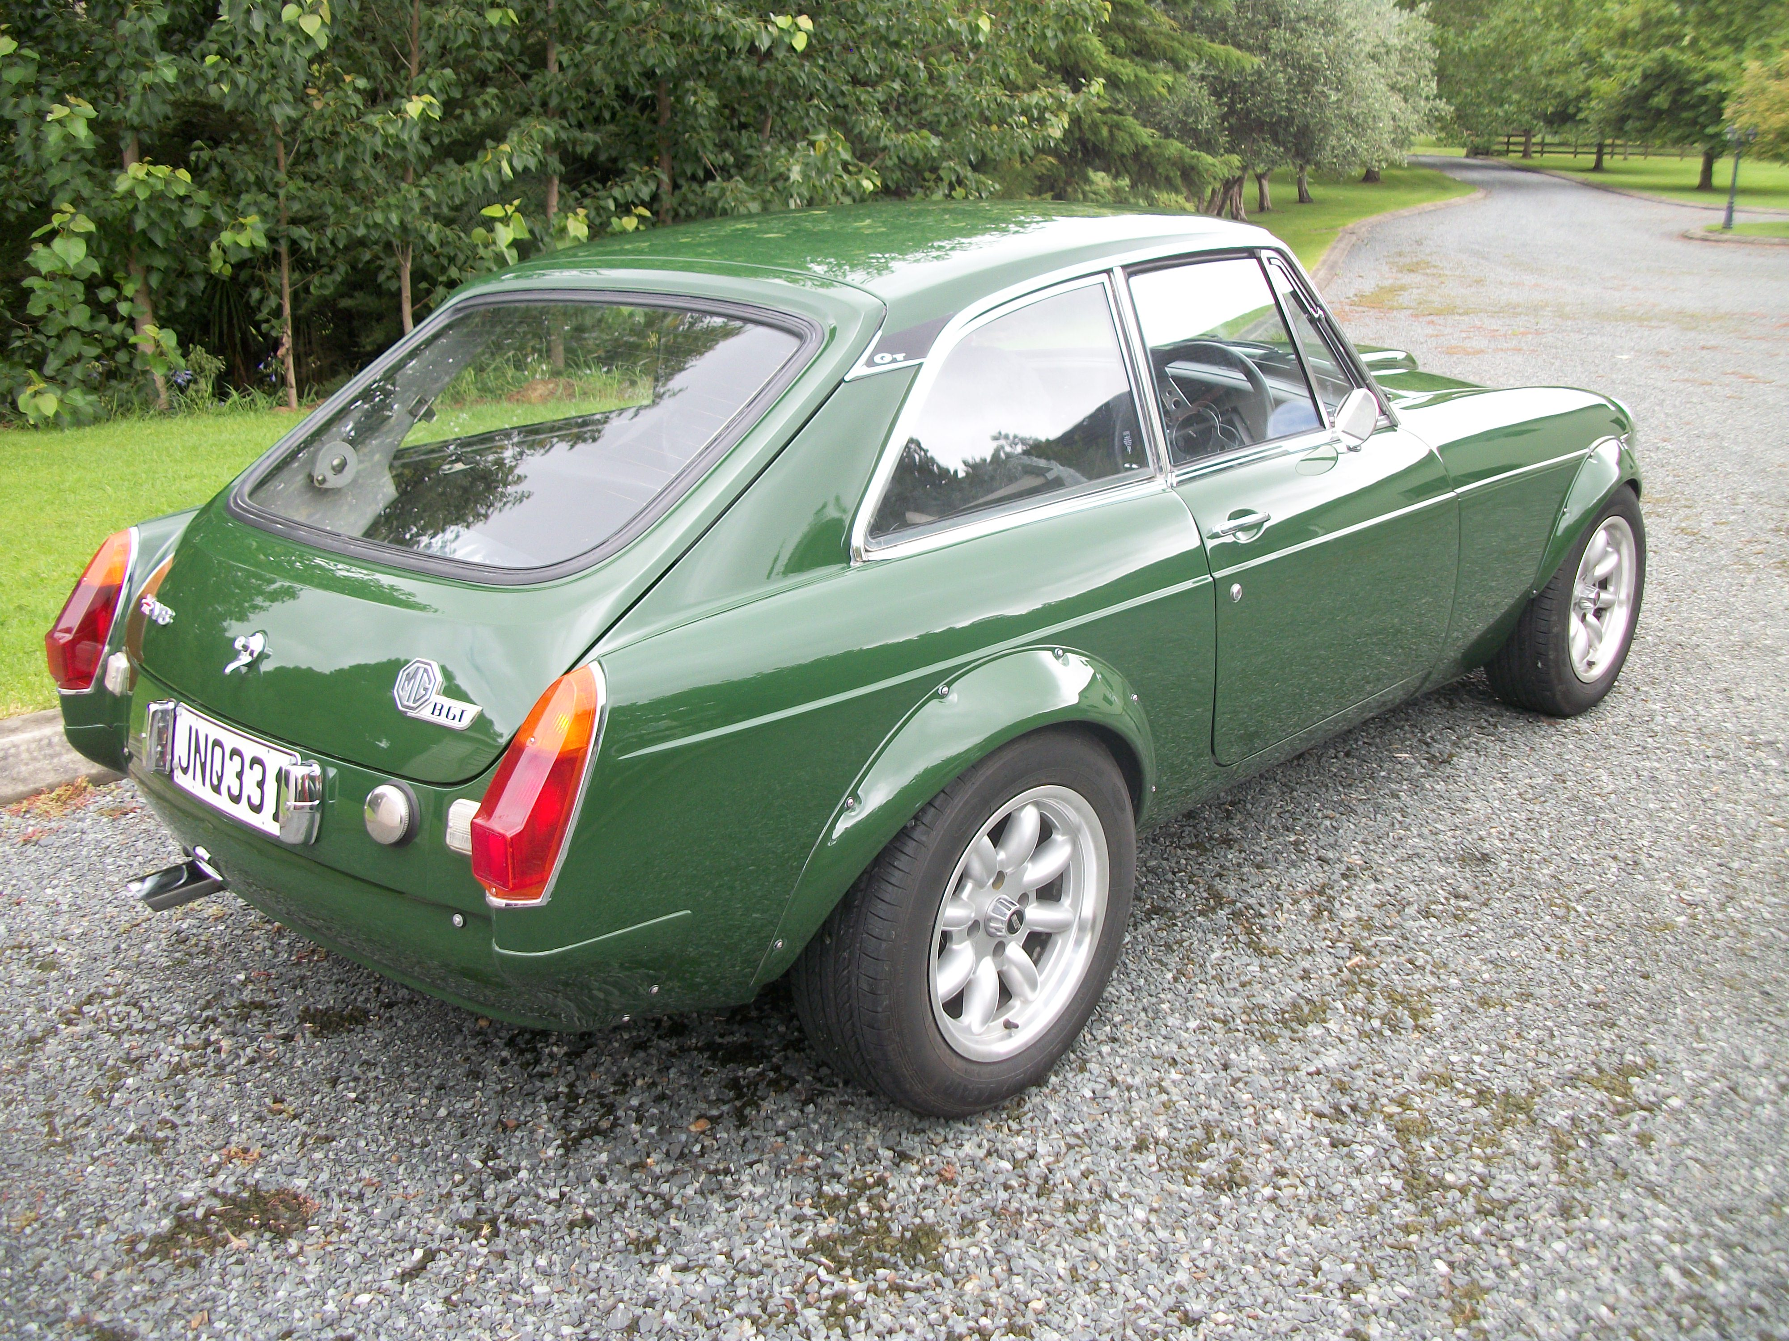

s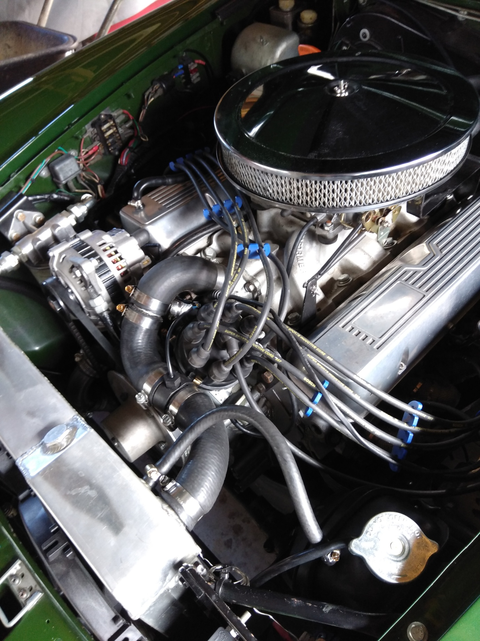

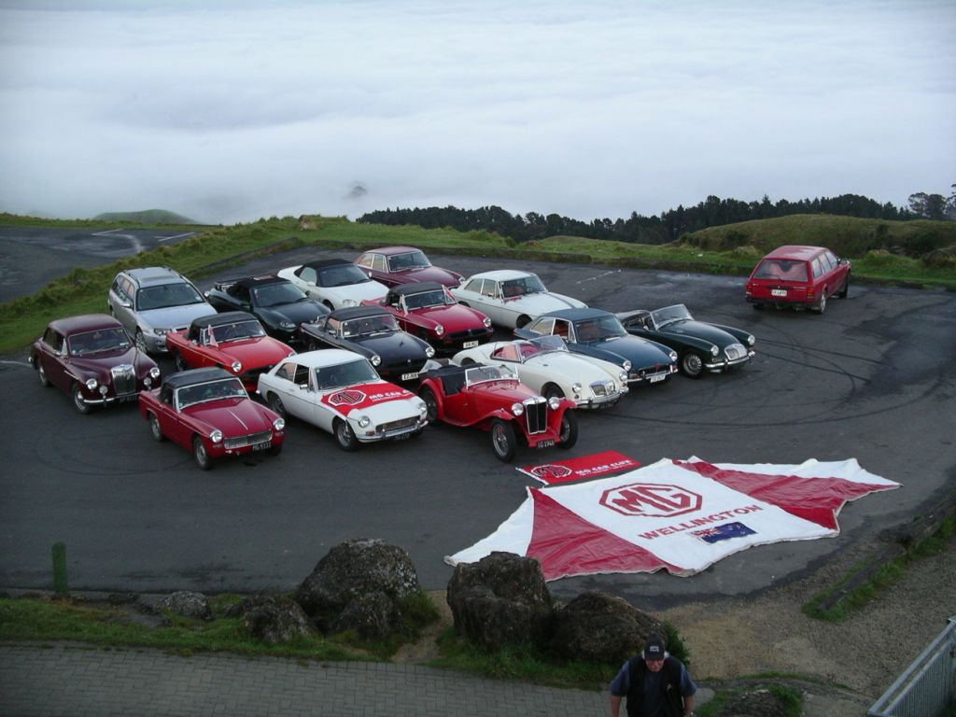
MGs at 80th Sunrise Te Mata Peak Hawkes Bay
Then we introduced it to the track as the “1st MGZTT 260 Safety Car world wide” at our MG Classic Race meeting in November. See photos below.
I should point out that the rego is ARFMG. I use that to wind up the Mustang lot who call me a cross dresser also. Actually, my initials and was first used on the Rover. Lots of meanings but ARealFastMG is good to go with.
It’s enormous fun to drive as Jeremy Clarkson noted:
“Think of it as the Merlin they used to put in P-51 fighters, an Anglo-American joint effort that is in no way as sophisticated as the creamy-smooth jets fitted to the German opposition, but a whole lot more charismatic and loveable nonetheless.”
“Twice, in the last run of Top Gear, I took this car onto the track simply to wake myself up, ready for the show. It got the adrenaline pumping and served as a reminder about why I fell in love with cars in the first place.”
Does it have issues, not major but yes. The worst one was the leak due to the flimsy plastic pipe used as drainage for the sun roof. Carpets sodden, full strip out and days to dry out. A $1 bit of proper pipe fixed this.
TV no longer works as we’re now digital, who cares. CD never worked but the V8 burble makes up for that. Haven’t paid BMW the $500 for the SatNav CD either and don’t worry about the MPG it’s better than the 67 Mustang.
Fan for radiator is also the A/C one, A/C side packed up as did the washer motor(s) but easy fix, just had to pull the front of. A 20-minute job that takes about 2 hours first time up.
Managed to get some NOS front rotors and pads very cheap from local MG agent closing down so they are in garage. Car can be hard on tyres also but it’s fun 😊
Otherwise just so much fun to drive, 50/50 front to rear balance and still looks great as a 14-year-old car. I still get a buzz just flooring it all the way to 100 kph. Great tow car also.
Top Gear test
VITAL STATISTICS
Model: MGZT 260
Engine type: V8, 4601cc
Power: 260bhp@ 5000rpm
Torque:302 lb ft @ 4000rpm
Transmission: Five-speed manual, rear-wheel drive
Acceleration: 0-60mph:6.2sec
Top speed:155mph (party trick, can go from 0 to 155 in fifth gear)
Price:£28,495 new that is NZ$55,565 in 2004 but sold here at over $60K I recall
Verdict: Confidence-inspiring,brilliantly involving, and exciting to drive. But could you cope with being aRover driver?
Not for sale
Cheers
Ross Armstrong (Wellington MG)

Don’t forget the MGCC Auckland’s ‘Mighty MG Run’ on Sunday 4th November, see www.mgclub.org.nz in ‘Events’ section. ALL WELCOME.
Cheers for now, Col Minton & Michael McCowan

Don’t be late drive a V8.

