An MG Life – Rex Thompson

As a young teenager I lived in Epsom. Nearby, on Manukau Rd was a service station with a show room next to it, which I passed on my way to work and back.
In the showroom were three or four new cars waiting for owners, and one was a brand-new cream TF 1500 on wires, the most gorgeous car I’d seen. Okay, I‘m going to have one of these come what may.
In those days, the mid 50s, new cars were almost impossible to get without overseas funds, and very expensive.
My first MG was a TC, which I purchased from a couple of Canadians who were moving on to Australia. It was in good condition and I drove it for 12 months and sold it for 400 hundred pounds, I had bought it for 350!
After the TC I bought a TF 1957. Garth Taylor came round one Saturday morning, “Rex we have a meeting on Sunday morning in Sandringham we are going to form an MG car club in Auckland”
There was an MG car club already in Christchurch, I cannot remember just how many of us or who was there, apart from Dick Alder, Rick Cammick, Frank Wilkins, Adrian Robinson, Garth Taylor, and so MG car club Auckland was born.
From time to time over the years I served on the committee. There was one instance at that time we had a membership application from one Anna Maria Hoffman. Anna at that time had a very nice black Y type saloon.
These were the days of 6 o’clock closing. Anna was well known in and around Auckland, and her favourite drinking establishment was the Occidental in Vulcan lane. Often on Friday nights there was a bit of a disturbance needing police intervention, with Anna in the thick of it. She was a legend in her own time, known as “the Black Witch of Kings Cross” reckoned to be the only female to be deported from Australia!
We on the committee, at that time and were a fine law-abiding lot and felt Anna would bring the club into disrepute, and so turned down her application.
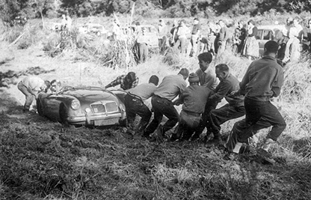
So, for the next couple of months every flat battery, flat tyre, parking ticket, etc Anna's shadow was always there!
My next car after the TF, was an Austin Healey 100-6. I think there were more Healey's than MG's in the club those days, this was the late 50's early 60's.
The Healey was not the car for me, and when the panel beaters got it straightened out, I sold it and bought an MGA.
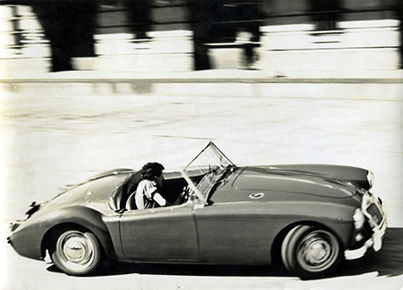
The club was well supported, and we would gather at the Picasso Coffee Bar, at the bottom of Grey's Ave on a Friday night. (where they would serve you beer after 6 o’clock in a coffee mug. Another popular gathering was on a Sunday evening convoy up to the hot pools at Waiwera.
Club president at that time was Darryl Sorrenson who also happened to be a traffic cop! He would frequently enjoy scaring us by lying in wait, and coming up behind with sirens and flashing lights.
Others at that time, Peter Elford, with his very large Humber Super Snipe, painted a delicate shade of undercoat grey, full of spares for his Cooper Bristol.
John Grant and his Cooper Bristol. John Caskie with the lemon and black Austin Healey 100-6. Ray and Joan Hughes TF 1500. Dick Alder MGA.
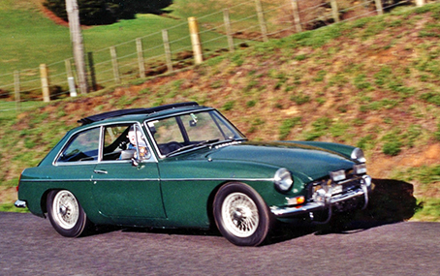
One of the highlights of the year was Easter at Wairaki, where we stayed in tents or cabins, the events much the same as today's Easter events, with concourse, motorkhana, trial, speed event, and an evening event called “bottles” as I recall.
Sheryl and I were married in 62 and the MGA became the deposit for our first home.
Family followed, and family friendly cars were the necessity.
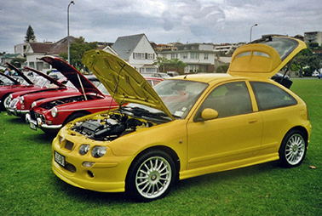
We rejoined the club in the eighties after purchasing a 1967 MGBGT. (the current owner of this car, Keith Farlow, has just recently joined the club,)
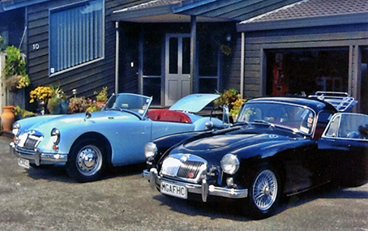
We were semi-competitive doing midget trials, rallies, closed club sprint, Far north, hill climbs, concours etc. We did not want to alter the car with roll cages and other “safety gear” that is required for serious competition. For a while we had two BGT.s as we bought a 1977 BGT with a rubber bumper, which we used as our everyday day car, and have now owned for over 30 years. Next car was a brand new, bright yellow, ZR.
Our current cars including the above MGBGT, includes a full set of MGA's. (that is a fixed head coupe and a roadster) and an MGF.
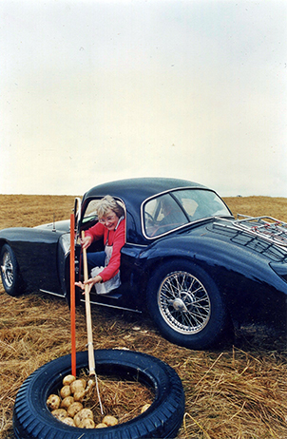
Sheryl has played a large part with the MG's, driven them all and competed in most events, winning trophies and certificates over the years.
We are not so competitive now, although still have a go at trialing, and enjoy touring and weekends away. Have attended most national rallies, and competed in them.
During the time in the club we have made many friends and enjoy the fellowship of other MG people.
For Sheryl and I it has been an interesting, fun journey, and there are still a few miles to go!

