REGISTER NEW ZEALAND
NEWSLETTER AUGUST 2017
Hi MG V8er’s, I hope you have had a great summer and got out in your cars to enjoy the great roads around Godzone. Ruth and I recently took part in the MGCC Auckland Winery Tour to the Hawkes Bay. We spent 3 days tasting the beautiful wine and food on offer and drove many miles of interesting roads around the Napier Hastings region. Not completely trouble free I’m afraid as one carburettor float stopped floating and had to be replaced. Luckily one of our touring party had a spare set in his car, albeit from a 4 cylinder car, with a minor adjustment we installed it and everything again worked fine. Many thanks to Colin Morse.
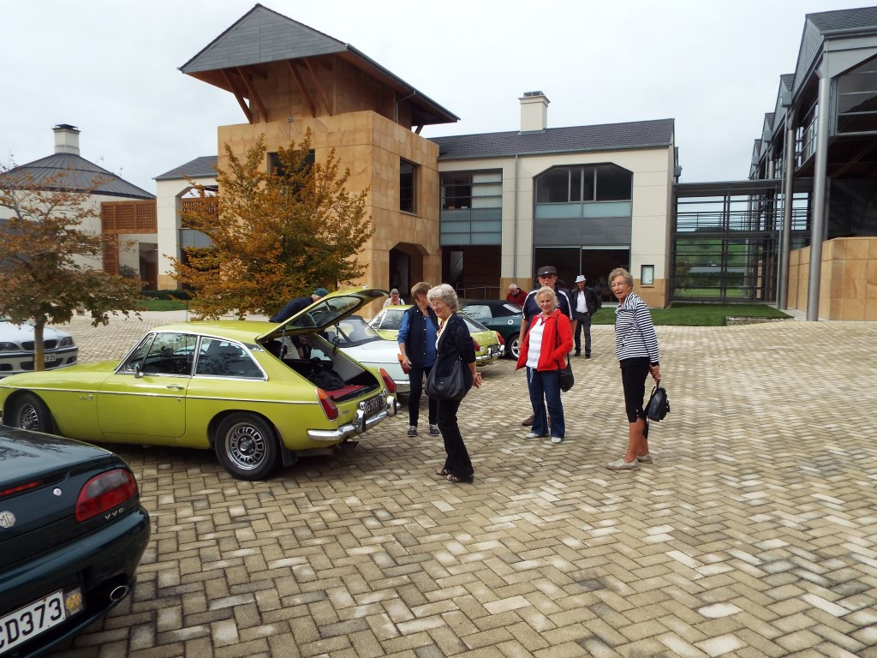
On the wine trail Napier.
I have asked Michael Wood to pen an article on his 1976 BGT V8 Toyota Supra gearbox conversion see below. As there are a few options to replace the original MG gearbox these days, this article may be of interest to you.
Also Tad Piggin has kindly written about his RV8 ownership.
GEARBOX CONVERSION
Michael Wood
Gearboxes have been an ongoing issue with MGB V8’s since the early conversions were undertaken by Ken Costello. Both Costello and the factory MGB GT V8’s used a gearbox similar to that of the four cylinder MGB, which showed its limitations when faced with the torque of the V8.
Since the late 1970’s many MGB V8 conversions have used the Rover LT77 five speed gearbox, and many factory built MGB V8’s have also used this gearbox. Whilst having the bonus of good gear ratios and compact size, the LT77 gearbox does not possess a particularly sporting gearchange and is not the most durable of gearboxes.
My 1976 BGT was converted to V8 in 1995, and was fitted with a reconditioned LT77 gearbox. At the time this gearbox was overhauled, new synchromesh cones were not available and so the best secondhand parts available were used. When I bought the car in 2004, it was obvious the gearbox was past its best. I had the synchro cones replaced with new items (which had since been remanufactured) but I was never entirely happy with the quality of the gearchange.
I began to look over other options a couple of years ago. A popular option in the UK is the Rover R380 gearbox, which replaced the LT77 and was fitted to the last RV8’s. Whilst a good gearbox, it is rare and therefore expensive. The Borg Warner T5 was a further option, however again price was an issue.
I was aware that the Toyota Supra gearbox had a good reputation, and has been fitted to several Rover V8 powered cars over the years. It is a very strong gearbox, and although it is becoming rare, it is sufficiently strong to handle normal road use without causing reliability issues. It also fits into the MGB transmission tunnel, requiring only crossmember modifications to enable the rear mounting to be correctly positioned.
I purchased a kit from Conversion Components in Hamilton, comprising the gearbox, selector mechanism modified for the MGB, bellhousing, and clutch components. Fitting was straightforward other than the need to have a new flywheel made, as the one previously fitted to my Rover V8 was not correct for the Toyota box.
The gearbox is a significant improvement over the LT77 in terms of gearchange and refinement. Whilst it is not the most sporting of gearchanges, it is precise and has excellent synchromesh. It is also extremely quiet, with no evidence of any whining or gear noise in any of the gears. The gate is slightly wider than the LT77, meaning that in order to avoid cutting the standard MGB tunnel, the gear lever ends up with a slight bend to the left – other than that, the gears work perfectly. The ratios are excellent, though 5th gear is slightly lower than the LT77 giving about another 100rpm in fifth gear at 100km/h. The clutch provided with the kit is slightly lighter than the Land Rover clutch I previously used, which eases the load of driving. Overall I am very pleased with the result of the conversion, which has made a significant improvement to driving the car.

My MG RV8 The Path to Ownership
Tad Piggin
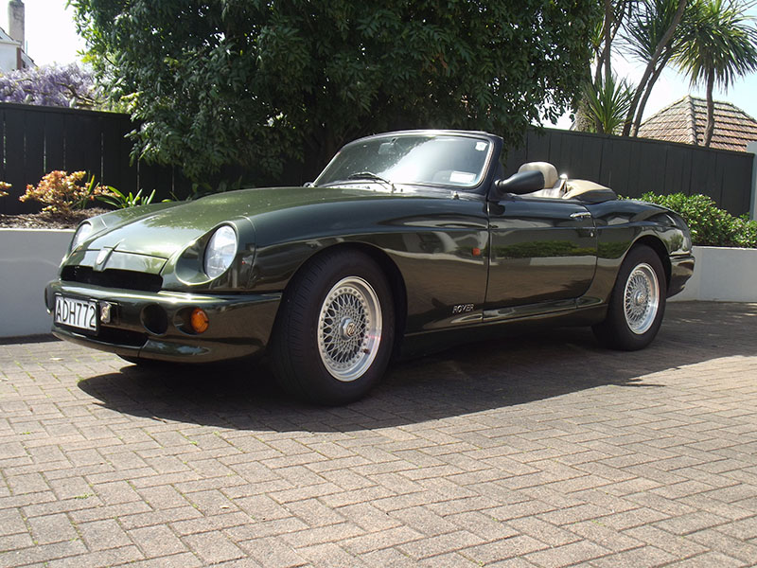
My ownership of an MG RV8 Vin number 1860 happened in November 2001 some six years after the last RV8 Vin number 2233 which was produced in 1995. The RV8 story known as Project Adder is well documented in MG books and magazine articles. In short the car went through a number of design iterations from the idea stage in the mid 1980s until the official launch at the Birmingham Motor Show in October 1992. The launch date was deliberately chosen to coincide with the 30th anniversary of the MGB (1962 – 1980) so as to establish a credible heritage connection and story of evolution from the very popular MGB. However the relatively high price tag at the time was controversial when compared to that of the “mass produced affordable MGB”. The RV8 was distinguishable by the rework of the heritage produced MGB body style, interior finish of leather and wood detail together with the Rover V8 motor under the bonnet. It was promoted in a low key press campaign and when production started in 1993 Jonathon Wood said “…the first example of its spiritual successor, the MG RV8, left the Cowley assembly line and with it has come the rebirth of the MG Marque”. To put this in perspective it was said that the RV8 was approximately 5% actual MGB parts, 20% derived therefrom and 75% completely new. Sales forecasts for the RV8 on MGs traditional home turf proved to be overly optimistic. By the time production ceased in 1995 (some 2000 cars) 80% would be exported to Japan and of those 80% were in the colour Woodcote Green. My car is ex Japan and that colour.
Some background to my particular road to ownership of an RV8. Until an evening in the mid 1990s at the unveiling of the MGF at the NZ BMW head office I had not contemplated let alone set eyes on an RV8 but there was one on display that had come via Australia. Both cars were stunning on their own merits – the mid engine completely new addition to the MG Marque and the RV8 in BRG oozing opulence and raw power.
Now fast forward to 2001. That year I owned a beautifully restored Old English White 1971 MGB Roadster (bought in 1995) and a Charcoal 1996 MGF VVC (bought in 1996). So the missing link in the model sequence was an RV8. The catalyst was a two page article by Sam Domett in the “Driver” magazine of September 2001 with the heading “Old Spice” followed by “We locate a very rare, very low mileage MG RV8. It takes us back to the days of hairy chested sports cars” and beside a photo “Once you turn the ignition people stop and stare. Instead of an anaemic four cylinder clatter there is a loud slightly off beat thrum from the eight cylinders that are breathing under the bonnet”. After much soul searching (dreaming) and cost justification, some rational some not, I convinced myself to buy the featured RV8 in November 2001.
Something had to give to make way for the RV8 and so the B went. To this day I wished I still owned the B as well and am certain I am not alone in the “regret” camp of former owners of cars one should never have sold. The MGF was also sold and later replaced with an 80th Anniversary MGTF 160.
Sixteen years of driving the RV8 (1378 km at time of purchase and now 28000 km) would put me into the category of owning a “toy for Sundays rather than a vehicle for primary transport” and thus classed as a so called “typical target customer” identified in “extensive customer research” as told by Steve Schlemmer the Adder Project Director in an article in “Enjoying MG” vol 12 number 11 November 1992. Regardless of the low kms there has been considerable on going maintenance of mechanical and body components mostly due to age rather than wear and tear. New tyres and the installation of a set of Spax shock absorbers were a good investment in enhancing the drivability and comfort of the car.
I wish to acknowledge the valuable advice and service received at the time of purchase through to 2012 from Terry Kelk formerly of Heritage Mechanical Services and the ongoing involvement of Neville Lucas of MG Classic Cars. Ownership of this classic car has been lots of fun and at times lots of $$$.
Further Reading:
Jim Dolbel’s website www.mgrv8.com
Jonathan Wood and Lionel Burrell “MGB The Illustrated History” Second edition 1993
David Knowles “MG V8” 2013

Jill & Ian Forbes have completed the chrome bumper upgrade and body repairs on their beautiful ‘Sonny Bill’ GTV8. Hope to have pics of the finished product soon.
Michael McCowan I believe has all but completed his GT chrome bumper conversion and rebuild, pics also to come next Newsletter.
I thought that I had better start going over ‘Grumpy’ and do a few minor jobs to prepare for the National Rally in Timaru next March, can’t leave these things to the last minute.
That’s it for now.
Happy MGing from Col Minton & Mike McCowan.
Don’t be late, buy a V8. (or two)

